Sanjai S 1260148042

Question 1

MATLAB APP FOR IMAGE SHAPENING

[file, path] = uigetfile({'*.png;*.jpg;*.tif;*.bmp'}, 'Select an image');

if isequal(file,0)

return;

end

img = imread(fullfile(path, file));

sharpDefault = imsharpen(img);

sharpCustom = imsharpen(img, 'Radius', 2, 'Amount', 1);

figure

subplot(1,3,1), imshow(img), title('Original Image');

subplot(1,3,2), imshow(sharpDefault), title('Sharpened (Default)');

subplot(1,3,3), imshow(sharpCustom), title('Sharpened (Radius=2, Amount=1)');

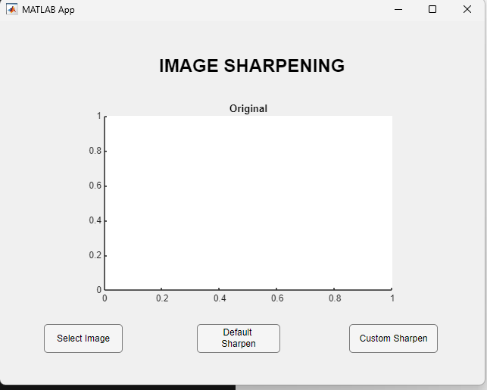

Image Sharpening Output

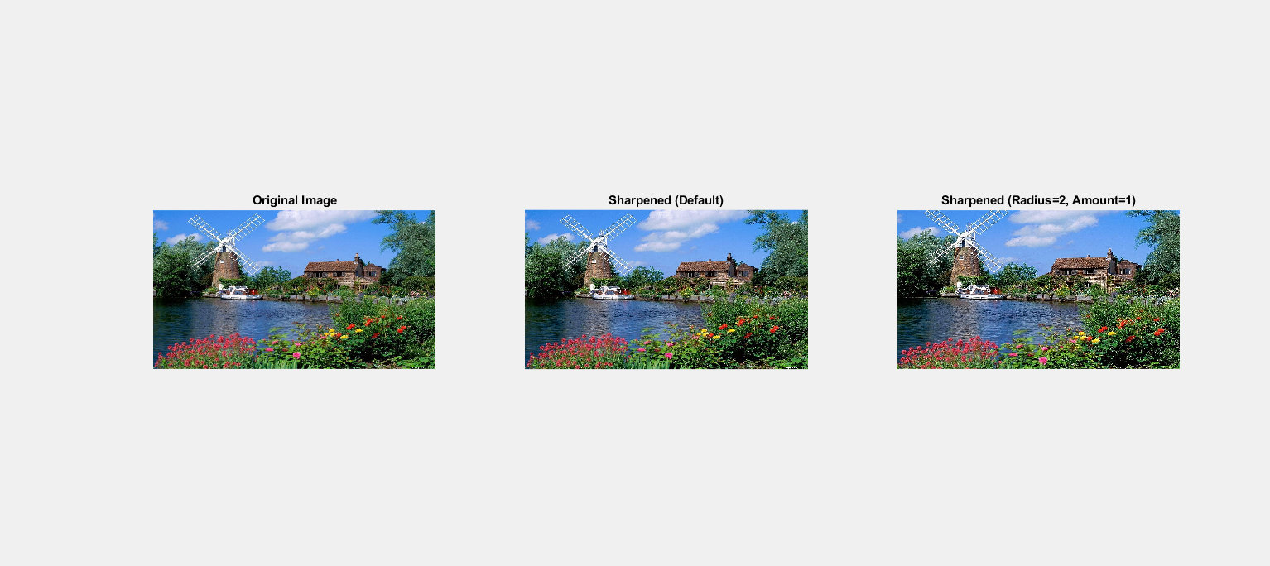

MATLAB APP FOR IMAGE SMOOTHENIG

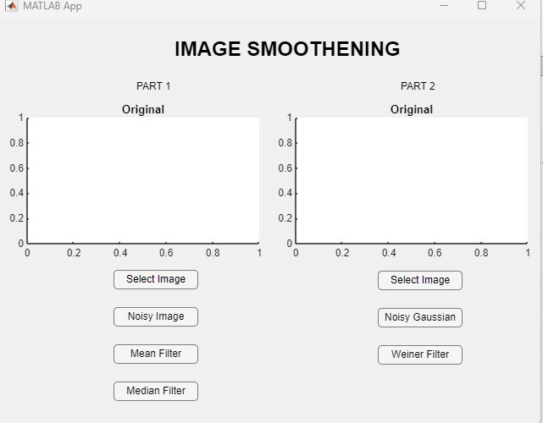 Salt & Pepper Noise + Mean & Median Filters

[file1, path1] = uigetfile({'*.tif;*.png;*.jpg;*.bmp'}, 'Select an image for Part 1');

if isequal(file1,0), error('No file selected.'); end

I = imread(fullfile(path1, file1));

J = imnoise(I, 'salt & pepper', 0.02);

if size(J,3) == 3, J = rgb2gray(J); end

% Apply filters

Kmean = filter2(fspecial('average',3), J)/255;

Kmedian = medfilt2(J);

figure('Name','Salt & Pepper Noise Filtering','NumberTitle','off');

subplot(2,2,1); imshow(I); title('Original Image');

subplot(2,2,2); imshow(J); title('Noisy Image');

subplot(2,2,3); imshow(Kmean); title('Mean Filtered');

subplot(2,2,4); imshow(Kmedian); title('Median Filtered');

Salt and Pepper Noise output

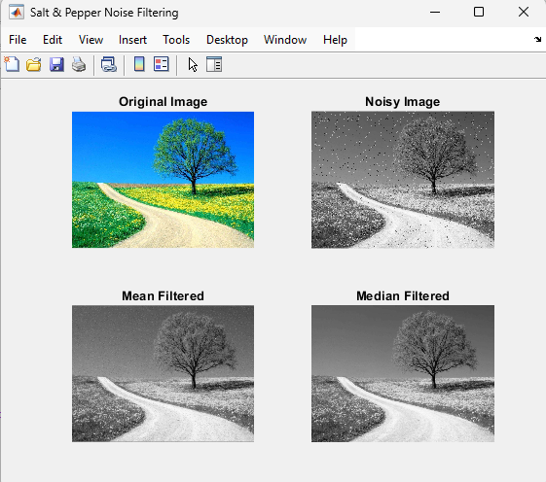

**Wiener Filter for Gaussian Noise**

[file2, path2] = uigetfile({'*.png;*.jpg;*.bmp;*.tif'}, 'Select an image for Part 2');

if isequal(file2,0), error('No file selected.'); end

RGB = imread(fullfile(path2, file2));

I2 = im2gray(RGB);

J2 = imnoise(I2, 'gaussian', 0, 0.025);

% Apply Wiener filter

K2 = wiener2(J2, [5 5]);

figure('Name','Wiener Filtering','NumberTitle','off');

subplot(1,2,1); imshow(J2(600:1000,1:600)); title('Noisy Portion');

subplot(1,2,2); imshow(K2(600:1000,1:600)); title('Wiener Filtered Portion');

Wiener Filtering Output

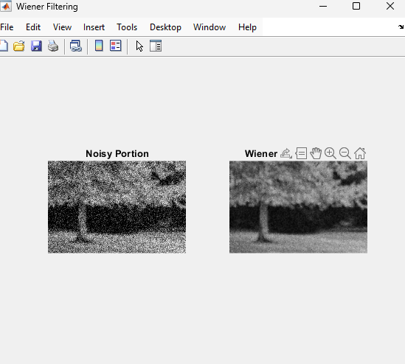

**Question – 2**

ip_folder ='E:\Vechicle\van';

op_folder = 'E:\Vechicle\van_processed';

if ~exist(op_folder,'dir')

mkdir(op_folder)

end

file_list = dir(fullfile(ip_folder,'*.jpg'));

for k = 1:length(file_list)

img = imread(fullfile(ip_folder,file_list(k).name));

if size(img,3)==3

gray = rgb2gray(img);

else

gray = img;

end

level = graythresh(gray);

bw = imbinarize(gray,level);

enhanced = imadjust(gray,[level,1],[0,1]);

figure;

subplot(1,3,1),imshow(gray),title('original grayscale');

subplot(1,3,2),imshow(bw),title('Threshold (otsu)');

subplot(1,3,3),imshow(enhanced),title('Contrast Enhanced');

imwrite(enhanced,fullfile(op_folder,file_list(k).name));

end

**single – ouput**

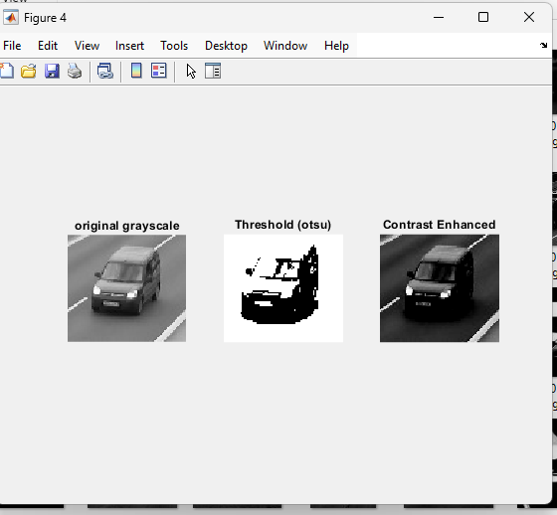

**original Truck dataset**

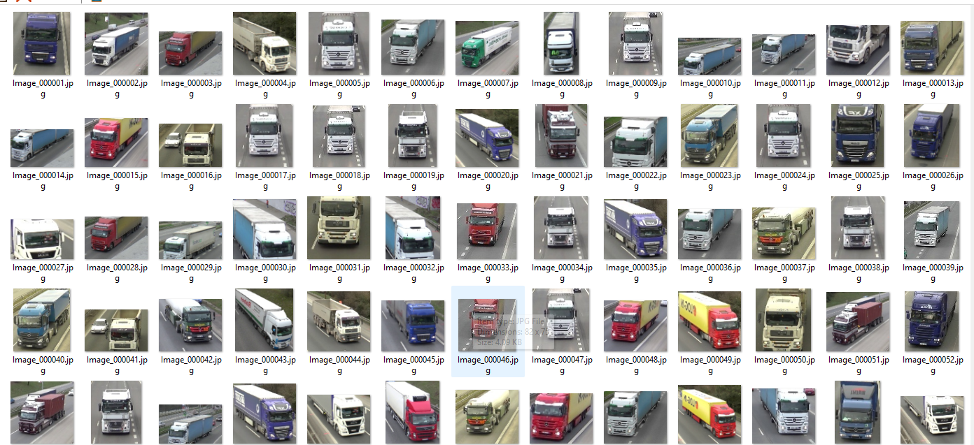

**Threshold Contrasted Truck Dataset**

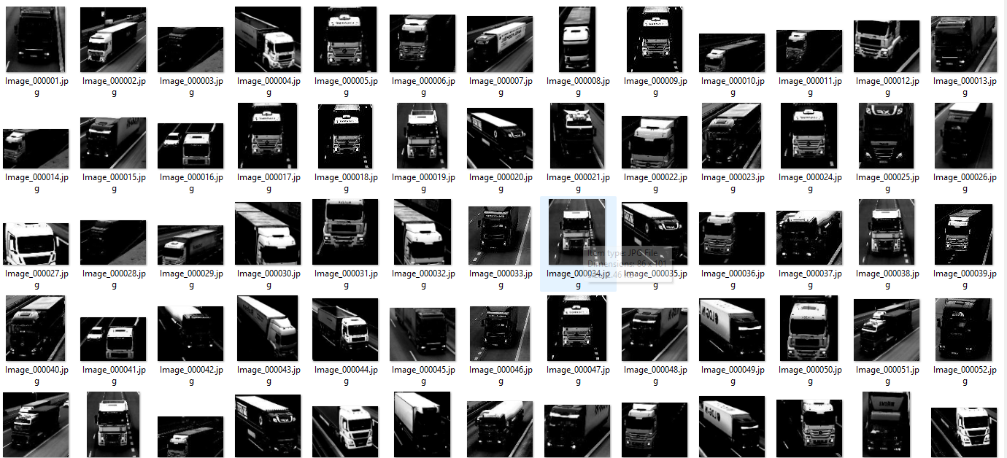

**original car dataset**

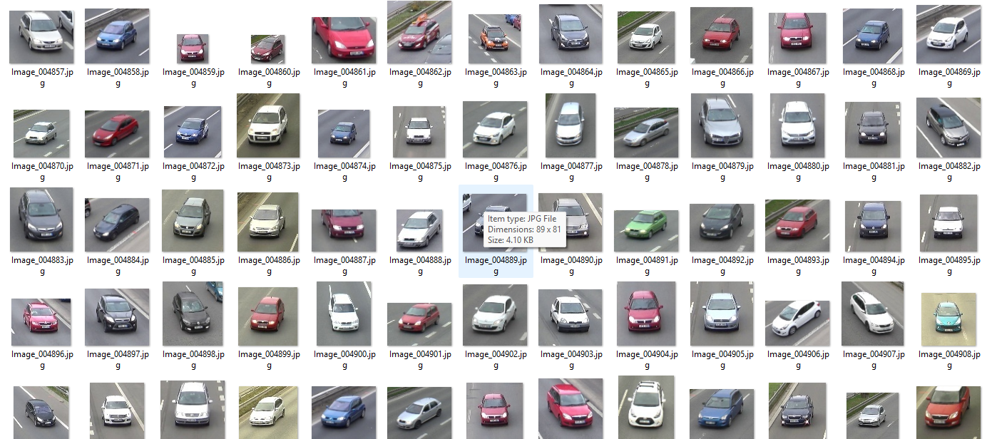

**contrast Threshold Cat Dataset**

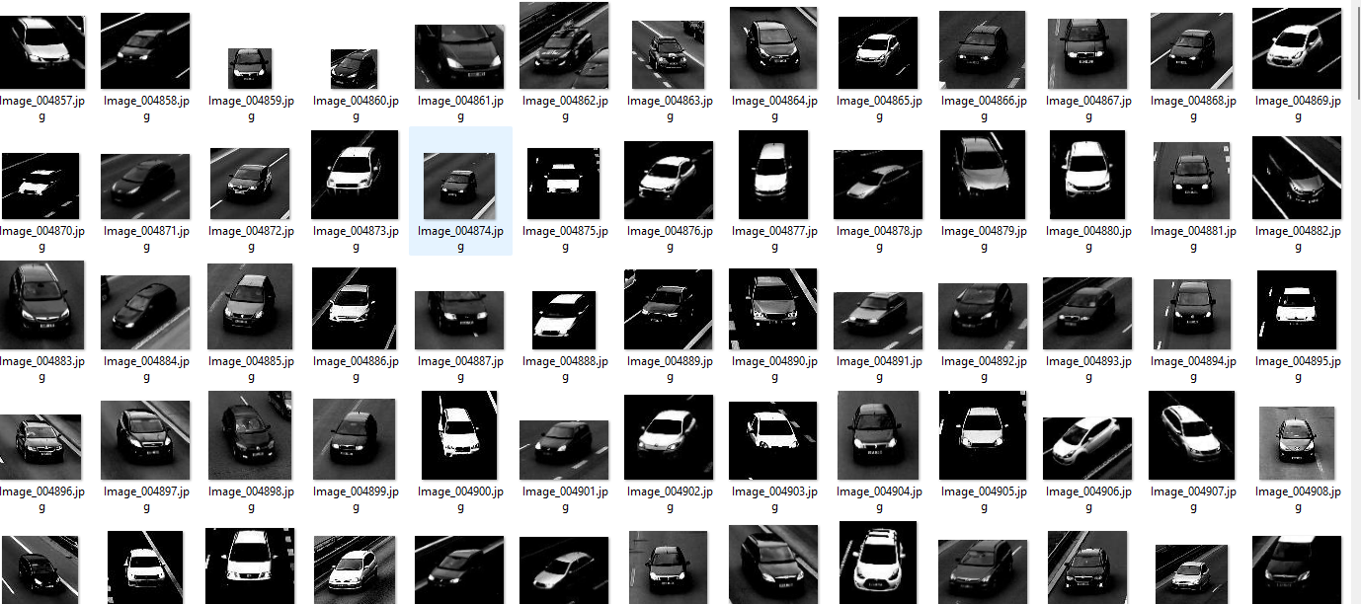

**original van dataset**

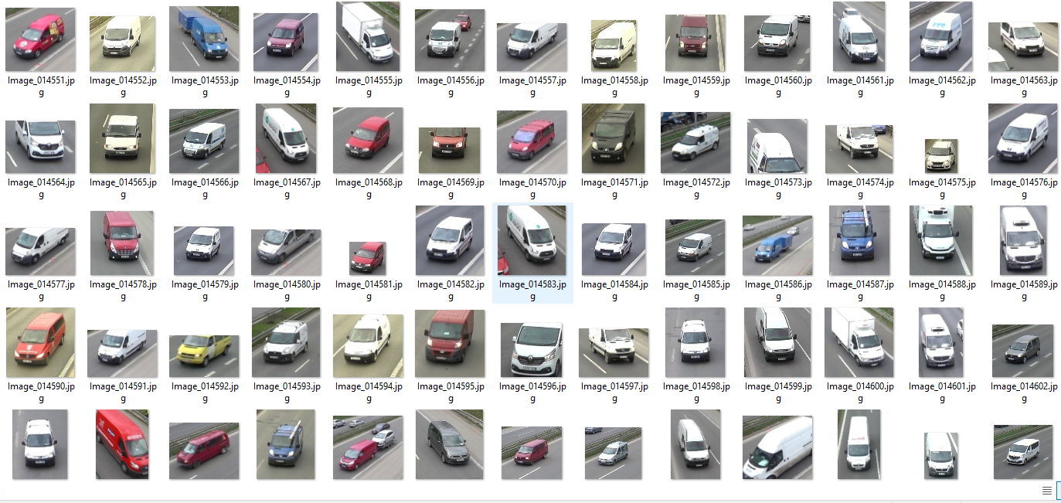

**contrast Threshold Van dataset**

